Thank You For Being My Hostess!


YOUR PARTY IS SCHEDULED FOR:

DATE: _________________________

TIME: _________________________

LOCATION:

__ MY HOME OR ___YOUR HOME

I’m so excited about our upcoming party! I can’t wait to share the latest and greatest
Mary Kay Products with you and your friends!

The information in this packet will help you have a terrific party. Follow the steps
outlined on the “Great Party Planner” flyer enclosed.

My goal is to pamper you and your friends and get you as much in free and discounted
products as you desire. When we work together, both our “Dreams” will come true!

This packet of information is for your use. You can keep any of the flyers you wish to
keep. You can return this packet to me with any remaining information at your party.
I will restock the packet to give to other Hostesses.

Please call me with any questions you may have. I will be contacting you soon for any
assistance I can give you to have a terrific party!

Donna Bayes, Mary Kay Independent Senior Sales Director
1852 Simmons St, Salina, KS
(Two blocks east of 9th and one block south of Cloud)
785-826-1740
donna@marykay.com

*Because this is my business and I love what I do, we will hold this party –
rain, sleet, snow or shine! If for some reason you would need to
re-schedule, please do so at least 48 hours in advance!
Thank you so much!

Great Party Planner



What to do:
- Read through this packet for ideas, inspiration and other fun stuff!

- Begin making your guest list. To ensure that 6 attend, invite 12!

- Tell everyone about your party.

- Make a note of any questions you might have and call me.

- Use the Outside Order form to begin collecting orders toward your goal.

- Fill out and mail invitations.

- Keep track of your RSVPs on your guest list form enclosed.

- A few days before your party, call anyone who has not contacted you to RSVP.

- The day before your party, call everyone who said “YES” to remind them of the time and to dress comfortably.

- Keep refreshments simple. Coffee/tea/soda and cookies are great! Make this an easy, enjoyable pampering time for you!

Donna Bayes, Mary Kay Independent Senior Sales Director
1852 Simmons St, Salina, KS
(Two blocks east of 9th and one block south of Cloud)
785-826-1740
donna@marykay.com
A Great Party Is All About
Great Friends!
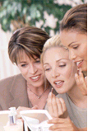

Great Friends Worksheet – who do you know?

Let’s take a minute to look at your circle of friends! Here is an easy way to list the people you know. Then choose who will be your select group to “Party” with!
* Remember to invite double what you intend to have!

Relatives! __________ __________ __________ __________

Relative’s Friends! __________ __________ __________ __________

Girlfriends! __________ __________ __________ __________

Co-Workers! __________ __________ __________ __________

Neighbors! __________ __________ __________ __________

Friends at Church! __________ __________ __________ __________

People You Would
Like to Know Better! __________ __________ __________ __________

Donna Bayes, Mary Kay Independent Senior Sales Director
1852 Simmons St, Salina, KS
(Two blocks east of 9th and one block south of Cloud)
785-826-1740
donna@marykay.com
Fill out the names, addresses and phone numbers of the people you are inviting to your party below.

Use this form to track your RSVP’s!

------------------------------------------------------------------------------------------------------------------
Name: _____________________________ Name: ______________________________
Address: ___________________________ Address: ____________________________
City/ST/Zip: ________________________ City/ST/Zip: _________________________
Phone: _____________________________ Phone: ______________________________
RSVP: _____________________________ RSVP: ______________________________
------------------------------------------------------------------------------------------------------------------
Name: _____________________________ Name: ______________________________
Address: ___________________________ Address: ____________________________
City/ST/Zip: ________________________ City/ST/Zip: _________________________
Phone: _____________________________ Phone: ______________________________
RSVP: _____________________________ RSVP: ______________________________
------------------------------------------------------------------------------------------------------------------
Name: _____________________________ Name: ______________________________
Address: ___________________________ Address: ____________________________
City/ST/Zip: ________________________ City/ST/Zip: _________________________
Phone: _____________________________ Phone: ______________________________
RSVP: _____________________________ RSVP: ______________________________
------------------------------------------------------------------------------------------------------------------
Name: _____________________________ Name: ______________________________
Address: ___________________________ Address: ____________________________
City/ST/Zip: ________________________ City/ST/Zip: _________________________
Phone: _____________________________ Phone: ______________________________
RSVP: _____________________________ RSVP: ______________________________
------------------------------------------------------------------------------------------------------------------
Name: _____________________________ Name: ______________________________
Address: ___________________________ Address: ____________________________
City/ST/Zip: ________________________ City/ST/Zip: _________________________
Phone: _____________________________ Phone: ______________________________
RSVP: _____________________________ RSVP: ______________________________
------------------------------------------------------------------------------------------------------------------
Name: _____________________________ Name: ______________________________
Address: ___________________________ Address: ____________________________
City/ST/Zip: ________________________ City/ST/Zip: _________________________
Phone: _____________________________ Phone: ______________________________
RSVP: _____________________________ RSVP: ______________________________
------------------------------------------------------------------------------------------------------------------

Donna Bayes, Mary Kay Independent Senior Sales Director

1852 Simmons St, Salina, KS
(Two blocks east of 9th and one block south of Cloud)
785-826-1740
donna@marykay.com

Outside Order Form 
Donna Bayes, Independent Senior Sales Director
--------------------------------------------------------------------------------------------------------
Customer Name: __________________________________Phone: _____________________
Address: ______________________________ City: ___________ State: _____ Zip: ______

Do you currently have a Mary Kay Consultant who services you? Yes No
If not, may I offer you a complimentary facial? Yes No

Product (s) Ordered: Retail Price:
_______________________________________________ ___________
_______________________________________________ ___________
_______________________________________________ ___________
Tax @ ________% = ___________ Tax: ___________
Total: ___________
----------------------------------------------------------------------------
Customer Name: __________________________________Phone: _____________________
Address: ______________________________ City: ___________ State: _____ Zip: ______

Do you currently have a Mary Kay Consultant who services you? Yes No
If not, may I offer you a complimentary facial? Yes No

Product (s) Ordered: Retail Price:
_______________________________________________ ___________
_______________________________________________ ___________
_______________________________________________ ___________
Tax @ ________% = ___________ Tax: ___________
Total: ___________
----------------------------------------------------------------------------
Customer Name: __________________________________Phone: _____________________
Address: ______________________________ City: ___________ State: _____ Zip: ______

Do you currently have a Mary Kay Consultant who services you? Yes No
If not, may I offer you a complimentary facial? Yes No

Product (s) Ordered: Retail Price:
_______________________________________________ ___________
_______________________________________________ ___________
_______________________________________________ ___________
Tax @ ________% = ___________ Tax: ___________
Total: ___________
----------------------------------------------------------------------------

Outside Order Form Donna Bayes, Independent Senior Sales Director
--------------------------------------------------------------------------------------------------------
Customer Name: __________________________________Phone: _____________________
Address: ______________________________ City: ___________ State: _____ Zip: ______

Do you currently have a Mary Kay Consultant who services you? Yes No
If not, may I offer you a complimentary facial? Yes No

Product (s) Ordered: Retail Price:
_______________________________________________ ___________
_______________________________________________ ___________
Tax @ ________% = ___________ Tax: ___________
Total: ___________
----------------------------------------------------------------------------
Customer Name: __________________________________Phone: _____________________
Address: ______________________________ City: ___________ State: _____ Zip: ______

Do you currently have a Mary Kay Consultant who services you? Yes No
If not, may I offer you a complimentary facial? Yes No

Product (s) Ordered: Retail Price:
_______________________________________________ ___________
_______________________________________________ ___________
Tax @ ________% = ___________ Tax: ___________
Total: ___________
----------------------------------------------------------------------------
Customer Name: __________________________________Phone: _____________________
Address: ______________________________ City: ___________ State: _____ Zip: ______

Do you currently have a Mary Kay Consultant who services you? Yes No
If not, may I offer you a complimentary facial? Yes No

Product (s) Ordered: Retail Price:
_______________________________________________ ___________
_______________________________________________ ___________
Tax @ ________% = ___________ Tax: ___________
Total: ___________
Customer Name: __________________________________Phone: _____________________
Address: ______________________________ City: ___________ State: _____ Zip: ______

Do you currently have a Mary Kay Consultant who services you? Yes No
If not, may I offer you a complimentary facial? Yes No

Product (s) Ordered: Retail Price:
_______________________________________________ ___________
_______________________________________________ ___________
Tax @ ________% = ___________ Tax: ___________
Total: ___________
----------------------------------------------------------------------------
Mary Kay – Enriching Women’s Lives!
It’s called the Beauty of Friendship!!

Women wear so many hats these days. Sometimes we are so busy we don’t have time anymore to do the little things that say to our family and friends – “Just wanted to let you know I was thinking of you”.

Well, during this special promotion, you can give up to 5 of your friends – absolutely free – a special gift and a private makeover!

I will give you a gift card where you can write a special note to be attached to a beautiful gift. The gift is beautifully wrapped in cellophane, tied with pink curly ribbons and will have your special note attached to be presented at her special pampering appointment. This wonderful surprise can be given to 5 of your friends free as a thoughtful gift coming from you!

It’s also a great idea for someone who could use a lift, a little cheering up, or someone who’s just had a baby.

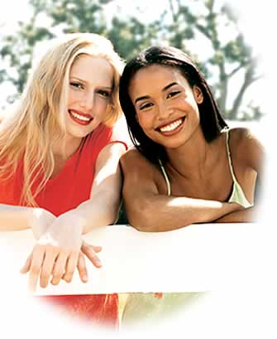
Who do you know that’s over-worked, over-tired,
over-stressed, and under-pampered?

List the women you would like to treat to a free pampering session, color makeover and a beautiful gift:

Name: _______________________ Name: _______________________
Relationship: _________________ Relationship: _________________
Phone: ____________________ Phone: ____________________

Name: _______________________ Name: _______________________
Relationship: _________________ Relationship: _________________
Phone: ____________________ Phone: ____________________

Girl’s Night Out Club



Become a Mary Kay Preferred Hostess, and you’ll receive the benefits that other client’s only dream of!! A preferred hostess is a client who selects 4 dates for “girlfriend fun” within the next year. You may choose from the follow parties:

Mary Kay 101 – Skin Care: Each guest will be pampering herself with Mary Kay’s scientifically formulated skin care system. This also includes basic color application and an opportunity for each guest to schedule their own personal appointment for Mary Kay 202 – advanced colors and techniques.

Sweet Dreams Night: Do you miss having “pajama parties”? Everyone comes dressed in their PJ’s and gets ready for bed with our wonderful skin care system. Guests will get to try our supplemental products customized for their skin’s special needs.

Tootsie Footsie Party.

Hairy Legs Party.

Spa Party.

Glamour Eyes.

Benefits of being a Preferred Hostess include:

- Up to $100 in free products at all classes
- 40% off all fragrances purchased throughout the year
- A beautifully wrapped gift on your birthday
- Special invitations to exclusive Mary Kay events
- Preferred Hostess Luncheon (held once a year)

(Appointments must consist of at least 5 guests and a minimum of $100 in sales. First appointment must be a MK 101)

Yes! I would like to be a Preferred Hostess!

Name: ____________________________ Home Phone: ____________Work Phone: ____________

Address: __________________________ City: __________________ ST:______ Zip: _________

Date of First Appointment*: _______________

Date of Second Appointment: _______________

Date of Third Appointment: _______________

Date of Fourth Appointment: _______________

*Your first appointment should be scheduled in the month that you join the program.
Mary Kay’s Hostess Program
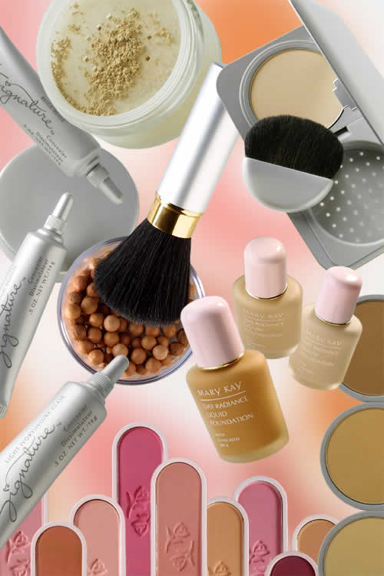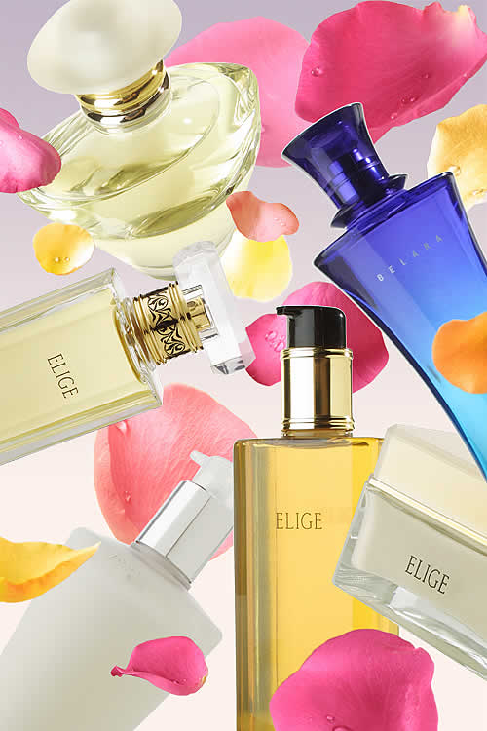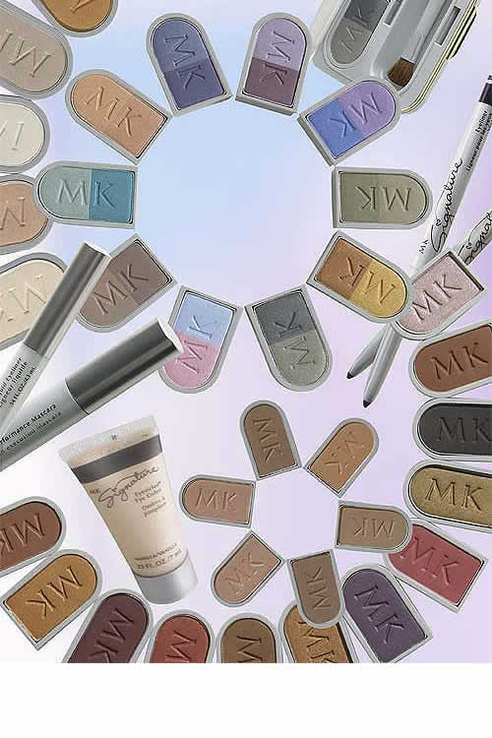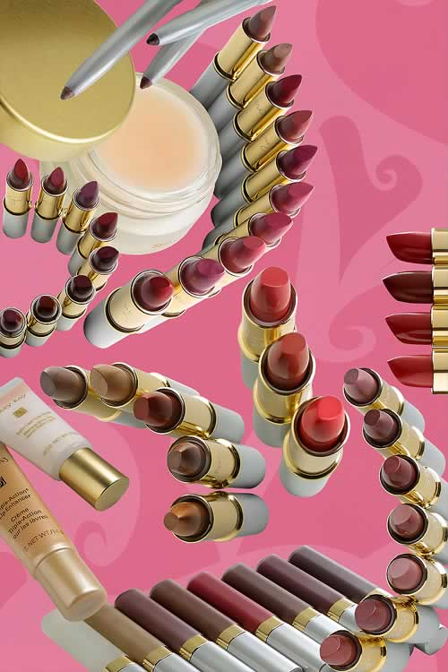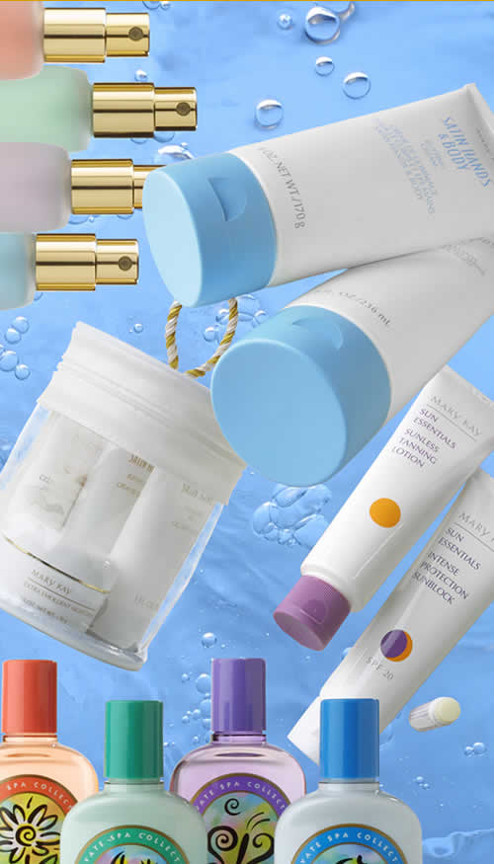

  - Earn 10% of your party’s total sales
in FREE PRODUCTS for sharing Mary Kay with 3 or
more friends! Outside orders count!

  - Earn 15% of your party’s total sales

in FREE PRODUCTS if one of your guest schedules
a party of her own!

  - Earn 20% of your party’s total sales

in FREE PRODUCTS if two or more of your guests
schedule their own parties!

  - Earn your FREE Professional Glamour
Brush Collection when you party is over $500
in retail sales! Outside orders count!

- Additional free gift for having your party on the original
date and time scheduled!

- Additional free gift for attending my weekly training as
my model.

A Tale of Two Hostesses

Congratulations, and way to go!
Lot’s of free gifts…you couldn’t say “no”!
Here’s a tale of two Hostesses, as you can see,
Read on, and pick the one you’d like to be!

First, there was Jane, so proper was she,
Her invitations were written in calligraphy!
“I’ll just invite six, I don’t know too many.
I’m sure they’ll all come, so there will be plenty.”

Her brochures and Hostess Booklet sat home on the table,
“Outside orders? She asked, “Oh, I wasn’t able.”
She prepared a buffet that was fit for a king,
But forgot to give her guests a reminder ring.
Only one guest arrived, the glamour to see,
“Why,” Jane wondered, “does this happen to me?”

And then there was Mary, so excited was she;
She was planning on getting her products for FREE!
She called 8-10 people, the date they were told,
She invited more people than the table would hold!

People wanted to know what the excitement was about,
So she’s stop and pull her catalog out.
She bragged about the products and the great guarantee;
Outside orders were no problem…no sir-ee!

She called the night before to remind once again,
And said, “Don’t forget about the prize you might win!”
She didn’t have time to prepare a buffet!
She stopped by the bakery, her class was that day.

Mary was thrilled with the products she won,
“Wow!” she exclaimed, “This really was fun!”

The moral of the story won’t leave you to brood;
Concentrate on your guests, not your home or the food!

Which Hostess Will You Be?

The Mary Kay Opportunity

Enriching Women’s Lives
An inspiring career. Boundless earning potential. The flexibility to create your own schedule. Time for your family and yourself. And the support of a remarkable community of women.

With Mary Kay, you can thrive as part of an international sisterhood – now 900,000 strong – committed to Mary Kay’s mission to enrich women’s lives. Where your work is more than a business or a paycheck. It’s a passion and a lifestyle, honing your skills, cultivating your talents and enhancing your income.

Unlimited Opportunity
Revenue opportunities in a Mary Kay business are numerous. Skin care classes and facials. Product reorders. Selling and ordering online. Customer programs. Team building. Or any combination. The choices are yours and the potential unlimited. A Mary Kay business provides an open-ended professional solution, free of glass ceilings and corporate downsizing. You are free to advance to the status you choose at your own pace.

- Approximately 900,000 Mary Kay Independent Beauty Consultants and Independent Sales
Directors serve customers in 33 countries worldwide.
- Over 13,000 women in the U.S. currently hold the position of Independent Sales Director, a
leadership role that signifies accomplishment and momentum.
- More than 250 women worldwide have attained Independent National Sales Director status,
the highest position in the independent sales force.

Mary Kay is a leader in providing Internet tools to help the independent sales force be successful in their businesses – like personalized Web sites that allow customers to order from Beauty Consultants 24 hours a day, seven days a week. In fact, about half of all product orders made by Beauty Consultants to the Company are now handled over the Internet.

Enterprising Women
Mary Kay, Inc. is committed to providing the necessary resources and support that will help you leverage your energy in the expansion of your own enterprise. Based on the highest ideals of integrity, resourcefulness and belief in women’s abilities, the Mary Kay vision continues to provide one of the most attractive pathways to financial independence, flexibility and fulfillment. Few other opportunities offer the best of so many worlds – the freedom to be your own boss, the infrastructure support of a multibillion-dollar corporation and the camaraderie of an enterprising and enlightened community of women.

When you start your Mary Kay Business, you’ll be joining the growing number of women-owned businesses that the U.S. Small Business Administration confirms are an international-driving economic force. According to a March 2000 SBA press release:

- There are 9.1 million women-owned businesses in the U.S., representing 40 percent of all businesses.
- Women-owned businesses generate more than $3.6 trillion in sales and employ 27.5 million people.
- Women are starting new firms at twice the rate of any other group.
Want to know more? Call or email me at anytime!

Donna Bayes, Mary Kay Independent Senior Sales Director
785-826-1740
donna@marykay.com

