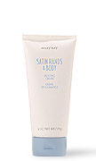
Simple Foot Facials Instructions
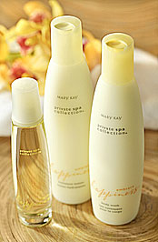
- Soak feet in tub of warm water filled with Private Spa Body Wash for 10 minutes.
- Take right foot out and smooth in Satin Hands & Body Buffing Cream all over foot – put back in water. Repeat on left foot.
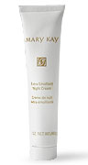
- Take right foot out, wash buffing cream off with wash cloth, dry with towel, and smooth in Extra Emollient Night Cream. Wrap in hand towel and place foot outside of foot tub.
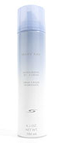
- Rinse left foot & wash off buffing cream with wash cloth. Take wash cloth and dampen leg from the knee down. (Leave foot in tub.)
- Smooth on Moisturizing Shave Cream from knee down – shave with disposable razor.
- Rinse leg and dry off with large towel.
- Smooth on Private Spa Moisture Lotion of choice on left leg and foot.
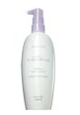
- Unwrap Right foot – wipe off remaining Night Cream.
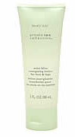
- Smooth Mint Bliss Energizing Lotion for Feet & Legs on foot and TimeWise Visibly Fit Lotion on right leg.
- Rinse off hands and apply Satin Hands Hand Cream
